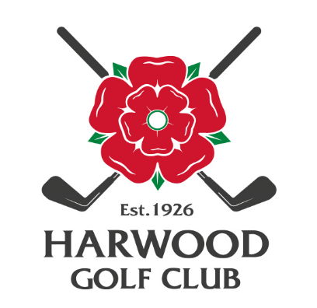
HARWOOD GOLF CLUB

Seniors Open Results
September 4th 2023

The Seniors Open was held at our Club on September 4th 2023. The weather was glorious and some very complimentary comments were received about the course and the efficiency of the administration, these included:

- The best view they had ever seen from the 8th fairway.
- The Greens are magnificent, then the but, - we couldn't read them!
- How have we never heard of this course before!

The prize winners are listed below:

- 1st Place: (P Dunne, A Simpson, D Harrison, J Cooke)
Greenmount GC - 104pts.
- 2nd Place: (K Rushton, M Anslow, P West, G Etchells)
Lowes Park G C – 93 pts – Card Playoff.
- 3rd Place: (Gary West, A Wrigley. R Heaton, P Cook)
Turton GC - 93pts - Card Playoff.

Nearest the Pin:

- 10th Hole: - G Clarke (Blackpool Park G C)
- 17th Hole: - B Stanley (Bury G C)

As always, the Club wishes to thank Geof Ward, John Ashworth and the terrific team of volunteers for their organization, support, advice and good humour on the day. Special thanks must also be given to our Greens’ Staff for all their work and presentation of our Course.

Kind Regards,

Alan.

Dr Alan Green.
Honorary Secretary.

